VETERANS DAY BREAKFAST
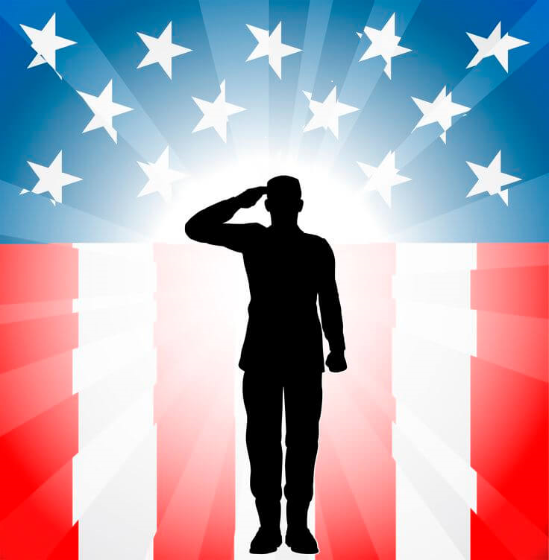

WEDNESDAY, NOVEMBER 11, 2026
9:00 a.m.
SHADE HIGH SCHOOL CAFETERIA

ALL VETERANS WELCOME!

THANK YOU FOR YOUR SERVICE!

Veterans who are not able to attend may request a breakfast be delivered to their home. Please call the high school office at 754-4648 by 8:30 a.m. on November 11, 2026 to request a delivered breakfast. The breakfast will be delivered on November 11.

